previous Index next

Scaling: Why Giants Don’t Exist
Michael Fowler, UVa 10/12/06

Galileo begins “Two New Sciences” with the striking observation that if two ships, one large and one small, have identical proportions and are constructed of the same materials, so that one is purely a scaled up version of the other in every respect, nevertheless the larger one will require proportionately more scaffolding and support on launching to prevent its breaking apart under its own weight. He goes on to point out that similar considerations apply to animals, the larger ones being more vulnerable to stress from their own weight (page 4):

Who does not know that a horse falling from a height of three or four cubits will break his bones, while a dog falling from the same height or a cat from a height of eight or ten cubits will suffer no injury? ... and just as smaller animals are proportionately stronger and more robust than the larger, so also smaller plants are able to stand up better than the larger. I am certain you both know that an oak two hundred cubits high would not be able to sustain its own branches if they were distributed as in a tree of ordinary size; and that nature cannot produce a horse as large as twenty ordinary horses or a giant ten times taller than an ordinary man unless by miracle or by greatly altering the proportions of his limbs and especially his bones, which would have to be considerably enlarged over the ordinary.

For more of the text, click here.

To see what Galileo is driving at here, consider a chandelier lighting fixture, with bulbs and shades on a wooden frame suspended from the middle of the ceiling by a thin rope, just sufficient to take its weight (taking the electrical supply wires to have negligible strength for this purpose). Suppose you like the design of this particular fixture, and would like to make an exactly similar one for a room twice as large in every dimension. The obvious approach is simply to double the dimensions of all components. Assuming essentially all the weight is in the wooden frame, its height, length and breadth will all be doubled, so its volume—and hence its weight—will increase eightfold. Now think about the rope between the chandelier and the ceiling. The new rope will be eight times bigger than the old rope just as the wooden frame was. But the weight-bearing capacity of a uniform rope does not depend on its length (unless it is so long that its own weight becomes important, which we take not to be the case here). How much weight a rope of given material will bear depends on the cross-sectional area of the rope, which is just a count of the number of rope fibers available to carry the weight. The crucial point is that if the rope has all its dimensions doubled, this cross-sectional area, and hence its weight-carrying capacity, is only increased fourfold. Therefore, the doubled rope will not be able to hold up the doubled chandelier, the weight of which increased eightfold. For the chandelier to stay up, it will be necessary to use a new rope which is considerably fatter than that given by just doubling the dimensions of the original rope.

This same problem arises when a weight is supported by a pillar of some kind. If enough weight is piled on to a stone pillar, it begins to crack and crumble. For a uniform material, the weight it can carry is proportional to the cross-sectional area. Thinking about doubling all the dimensions of a stone building supported on stone pillars, we see that the weights are all increased eightfold, but the supporting capacities only go up fourfold. Obviously, there is a definite limit to how many times the dimensions can be doubled and we still have a stable building.

As Galileo points out, this all applies to animals and humans too (page 130): “(large) increase in height can be accomplished only by employing a material which is harder and stronger than usual, or by enlarging the size of the bones, thus changing their shape until the form and appearance of the animals suggests a monstrosity.”

He even draws a picture:

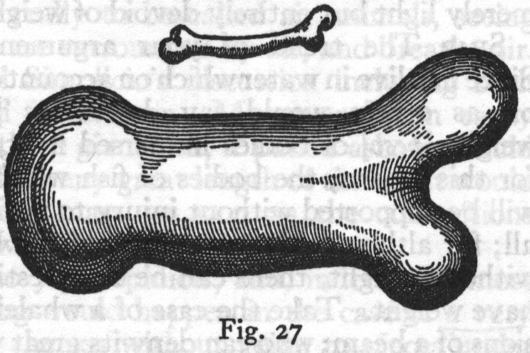

Galileo understood that you cannot have a creature looking a lot like an ordinary gorilla except that it’s sixty feet high. What about Harry Potter’s friend Hagrid? Apparently he’s twice normal height (according to the book) and three times normal width (although he doesn’t look it on this link). But even that’s not enough extra width (if the bone width is in proportion).

There is a famous essay on this point by the biologist J. B. S. Haldane, in which he talks of the more venerable giants in Pilgrim’s Progress, who were ten times bigger than humans in every dimension, so their weight would have been a thousand times larger, say eighty tons or so. As Haldane says, their thighbones would only have a hundred times the cross section of a human thighbone, which is known to break if stressed by ten times the weight it normally carries. So these giants would break their thighbones on their first step. Or course, big creatures could get around this if they could evolve a stronger skeletal material, but so far this hasn’t happened.

Another example of the importance of size used by Galileo comes from considering a round stone falling through water at its terminal speed. What happens if we consider a stone of the same material and shape, but one-tenth the radius? It falls much more slowly. Its weight is down by a factor of one-thousand, but the surface area, which gives rise to the frictional retardation, is only down by a factor of one hundred. Thus a fine powder in water---mud, in other words---may take days to settle, even though a stone of the same material will fall the same distance in a second or two. The point here is that as we look on smaller scales, gravity becomes less and less important compared with viscosity, or air resistance—this is why an insect is not harmed by falling from a tree.

This ratio of surface area to volume has also played a crucial role in evolution, as pointed out by Haldane. Almost all life is made up of cells which have quite similar oxygen requirements. A microscopic creature, such as the tiny worm rotifer, absorbs oxygen over its entire surface, and the oxygen rapidly diffuses to all the cells. As larger creatures evolved, if the shape stayed the same more or less, the surface area went down relative to the volume, so it became more difficult to absorb enough oxygen. Insects, for example, have many tiny blind tubes over the surface of their bodies which air enters and diffuses into finer tubes to reach all parts of the body. The limitations on how well air will diffuse are determined by the properties of air, and diffusion beyond a quarter-inch or so takes a long time, so this limits the size of insects. Giant ants like those in the old movie “Them” wouldn’t be able to breathe!

The evolutionary breakthrough to larger size animals came with the development of blood circulation as a means of distributing oxygen (and other nutrients). Even so, for animals of our size, there has to be a tremendous surface area available for oxygen absorption. This was achieved by the development of lungs—the lungs of an adult human have a surface area of a hundred square meters approximately. Going back to the microscopic worm rotifer, it has a simple straight tube gut to absorb nutrients from food. Again, if larger creatures have about the same requirements per cell, and the gut surface absorbs nutrients at the same rate, problems arise because the surface area of the gut increases more slowly than the number of cells needing to be fed as the size of the creature is increased. this problem is handled by replacing the straight tube gut by one with many convolutions, in which also the smooth surface is replaced by one with many tiny folds to increase surface area. Thus many of the complications of internal human anatomy can be understood as strategies that have evolved for increasing available surface area per cell for oxygen and nutrient absorption towards what it is for simpler but much smaller creatures.

On the other hand, there is some good news about being big—it makes it feasible to maintain a constant body temperature. This has several advantages. For example, it is easier to evolve efficient muscles if they are only required to function in a narrow range of temperatures than if they must perform well over a wide range of temperatures. However, this temperature control comes at a price. Warm blooded creatures (unlike insects) must devote a substantial part of their food energy simply to keeping warm. For an adult human, this is a pound or two of food per day. For a mouse, which has about one-twentieth the dimensions of a human, and hence twenty times the surface area per unit volume, the required food for maintaining the same body temperature is twenty times as much as a fraction of body weight, and a mouse must consume a quarter of its own body weight daily just to stay warm. This is why, in the arctic land of Spitzbergen, the smallest mammal is the fox.

How high can a giant flea jump? Suppose we know that a regular flea can jump to a height of three feet, and a giant flea is one hundred times larger in all dimensions, so its weight is up by a factor of a million. Its amount of muscle is also up by a factor of a million, and when it jumps it rapidly transforms chemical energy stored in the muscle into kinetic energy, which then goes to gravitational potential energy on the upward flight. But the amount of energy stored in the muscle and the weight to be lifted are up by the same factor, so we conclude that the giant flea can also jump three feet! We can also use this argument in reverse—a shrunken human (as in I shrunk the kids) could jump the same height as a normal human, again about three feet, say. So the tiny housewife trapped in her kitchen sink in the movie could have just jumped out, which she’d better do fast, because she’s probably very hungry!

Question: from The Economist, Sept 16, 1995 page 74: "the average 16-year-old Japanese girl has grown 4% heavier since 1975, although she is only 1% taller." Just how much plumper does she look? What percent increase would keep her shape exactly the same?
_______________________________________________________________________________

Teaching note: I began the lecture with five questions in a powerpoint presentation, to be answered using clickers. The idea was to get the class thinking about how areas and volumes increase when an object increases in size, keeping the same proportions. To understand how doubling the diameter of a circle increases its area fourfold, imagine the circle just fitting inside a square. It’s obvious what happens for squares—and also that the circle takes up the same percentage of the square’s area no matter what size they are, provided it just fits. Then a cube, and a ball in a cubical box. Think first about a 2x2x2 cube made of a child’s cubical building blocks. Visualize both volume and area increase from 1x1x1.

The last two questions were asked later, at the appropriate point in the class.
____________________________________________________________________________

previous Index next

